PRESS RELEASE
K+G Wetter GmbH
March 2021
Cleaning chamber

A clean solution for safe food production
Cleaning chamber from K+G Wetter ensures double hygienic safety when grinding

With its smart machines, innovation leader K+G Wetter ensures reliable safety and hygiene in production – together with products of first-class quality. The traditional company combines proven quality and modern food processing requirements with its intelligent solutions.

“Our claim is to continuously develop our designs and deliver solutions that are perfectly matched to the daily requirements of the butcher trade and industry. This is therefore precisely the basis from which we design specific user-oriented solutions for practical applications. An example of this is the cleaning chambers that we incorporate into our grinders and mixer grinders as standard”, explains International Sales Manager Volker Schlosser.

During the grinding process, the product is conveyed through the cutting set at very high pressure. Fluid product components such as blood, meat juice and liquids, or even small product particles, can be forced backwards against the cutting set by the resulting pressure.

Efficient solution for double hygienic safety

The high pressure and microscopic imperfections in the components allow microorganisms to bypass the seals. Once they have bypassed the seals, such organisms are able to proliferate in the relatively undisturbed conditions encountered there. Where the bacterial population is sufficient, the material undergoing processing can become contaminated. Cleaning seals from both sides is good practice for avoiding this effect. Cleaning the reverse side of the seals cannot normally be carried out on the worm drive of a meat grinder because the inside of the machine is not easily accessible to the cleaning personnel.

“Our ‘cleaning chamber’ hygienic solution, which we have successfully installed in our meat grinders for many years, offers a remedy here,” explains Volker Schlosser, “because it allows us to rinse the back of the seal from the outside using a cleaning agent and water jet. This means that both sides of the seal are cleaned. The foundation for germ-life is thus effectively destroyed.” Another seal is installed towards the drive to protect it from water. The cleaning water is directed out of the cleaning chamber onto the floor via a drain pipe, so that water is unable to remain inside the cleaning chamber. Even with older seals that have received insufficient maintenance or that exhibit wear, the cleaning chamber ensures proper cleaning of this critical area and the effective removal of deposits.

This technical detail is invisible from the outside, but it plays a key role in terms of hygiene safety and pure, unadulterated enjoyment.

K+G Wetter
K+G Wetter is a global partner of choice when it comes to manufacturing high-quality, reliable meat-processing machinery. K+G Wetter develops advanced cutters, grinders and mixers for butchers and skilled workers in the meat-processing trade and industry. The company's sophisticated technology and high-quality processing mean that machines from K+G Wetter contribute significantly to customers' business success. As a world-famous brand, the company from the Breidenstein district of Biedenkopf, in the German State of Hesse, supports its customers with personal and individual advice.
www.kgwetter.de

Press image 1:

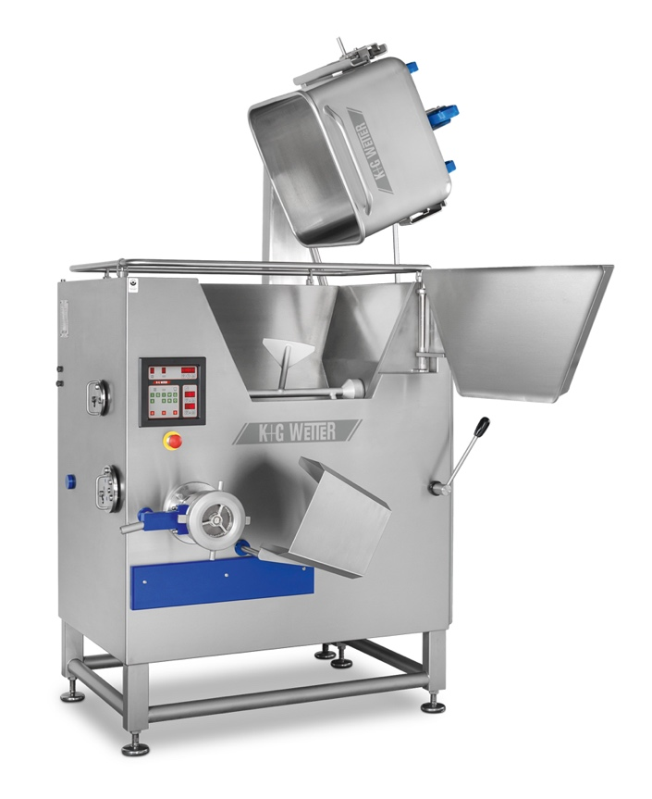

© K+G Wetter

Photo caption: The clever details make all the difference: Innovation leader K+ G Wetter combines proven quality with the requirements of modern food processing in all of its machines.

Press image 2:

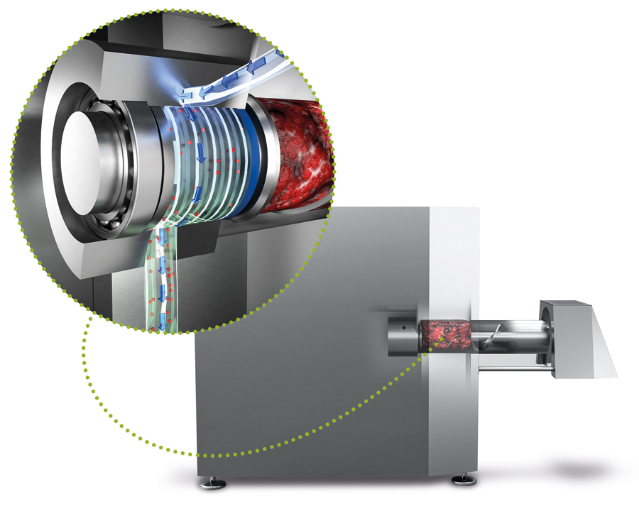
© K+G Wetter

Photo caption: Fitted as standard equipment to every K+G Wetter grinder and mixer grinder – cleaning chambers are an example of user-oriented solutions with an added level of hygienic safety.

Contact information:
K+G Wetter GmbH
Goldbergstrasse 21
35216 Biedenkopf-Breidenstein
www.kgwetter.de

Your contact partner:

Katharina Hennig
PR/Media
T. +49 (0) 2 71 . 77 00 16 - 160
F. +49 (0) 2 71 . 77 00 16 - 29
k.hennig@psv-neo.de
www.psv-marketing.de

