PRESS RELEASE
K+G Wetter GmbH
April 2024

Clean machine technology for outstanding pet food quality
K+G Wetter with first ever appearance at Interzoo in Nuremberg

Grinders, mixer grinders and cutters with the right twist for pet food: For the first time, K+G Wetter will have its own stand at Interzoo in Nuremberg to show what sophisticated food processing machines can do for pet food production - in terms of quality and hygiene, versatility and efficiency.
In Hall 4A, Stand 412, the meat processing machine manufacturer from Hesse will be presenting a selection of medium-sized machines: "This will give customers from the pet food sector an idea of the features we offer in machines of all sizes," says Volker Schlosser, Sales Manager International at K+G Wetter. "We are always open to our customers' requirements, consider all the important issues in meat processing and use them to develop ingenious grinder and cutter technology."
Accordingly, with these machines everything runs smoothly in the growing global animal feed market - more and more producers are relying on grinders and bowl cutters from K+G Wetter, both smaller producers and large industrial customers.

VetConcept: two K+G Wetter grinders for special animal feed
One of these satisfied customers is VetConcept. The German specialty food manufacturer produces dietetic food for dogs and cats with certain health problems, or also tailored to age, activity and breed.
Master butcher Arthur Schäfer, as plant manager, had two automatic grinders from K+G Wetter at the top of his wish list when planning the new wet food plant.
"At my training company we enjoyed super cooperation, so it didn’t occur to me to choose any other option other than K+G Wetter as the manufacturer. The grinders are good, they work really well," says Arthur Schäfer about the two AW 280 industrial grinders. "For our many products and the high tonnage per hour, it was crucial that we can do everything from frozen meat to fresh produce with these machines."
Raw materials containing bones? No problem for the industrial grinders either: "Bones are a natural source of calcium for our feed varieties. It's the same as the animal would eat in nature," reports Arthur Schäfer. "The grinder used must have the necessary power and robustness to crush the extremely hard material."

Hygiene issues neatly resolved
K+G Wetter has also cleanly solved all hygiene issues. The challenge at VetConcept: "As we produce special food, we have to have very clear batch separation. For example, we produce monoprotein varieties such as horse, kangaroo or goat. When changing batches, everything on the machine has to be super clean to protect sensitive and allergic animals from unwanted proteins," explains plant manager Schäfer. "So we also have to clean the machines quickly and easily between batches. This works very well with the grinders from K+G Wetter."
A special feature of the K+G Wetter grinders is the cleaning chamber, which eliminates a typical hygiene risk with grinders: The grinding process generates very high pressure. Liquid product components or even small product particles can be pressed through the seals into the machine interior against the cutting set and form deposits there. These particles are collected in the cleaning chamber and, are rinsed out and do not provide a breeding ground for germs. "We have converted the cleaning chamber so that the connections fit with our CIP system, foam goes in there, warm water, that works," says Arthur Schäfer about the customization for VetConcept at the K+G Wetter grinders. The additional time required for cleaning is negligible, with maximum hygiene effect.

Technology for thousands of tons
Industrial machines such as the automatic grinders from K+G Wetter are a major investment in which sustainability plays a major role; after all, they are designed to function for many years and process tens of thousands of tons of raw materials. "The animal feed market is growing enormously, between 15 and 25 percent per year. As a producer, you have to keep up with this, of course," says Arthur Schäfer. To ensure that the machines also keep up with this pace in the long term, K+G Wetter relies on a proven, robust design and the right twist on clever technology for hygiene and handling.

Press photos: K+G Wetter

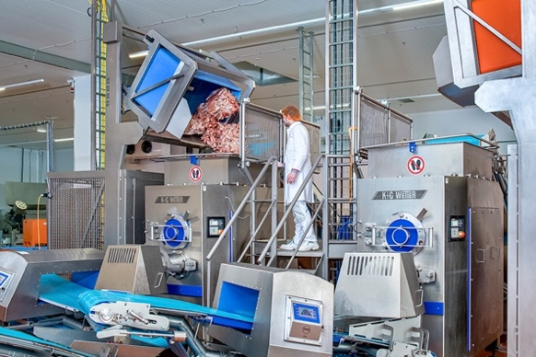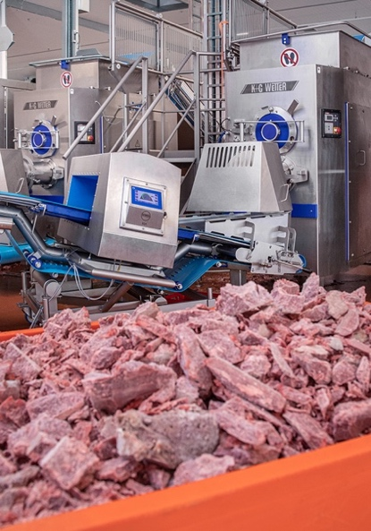
IMG_7812 and IMG_7925: At the heart of VetConcept’s wet feed production are two AW 280s from K+G Wetter. The industrial automatic grinders with a cutting set diameter of 280 mm process frozen meat and raw materials containing bones – perfect for pet food.

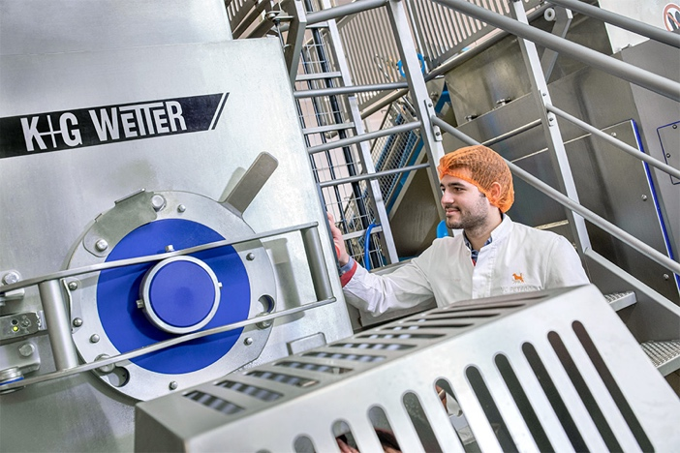
IMG_7828: All K+G Wetter machines are consistently optimised for hygienic design. Thanks to the closed housing made of hand-polished stainless steel and carefully ground smooth weld seams, the automatic grinders offer optimal cleaning characteristics. At VetConcept, plant manager Arthur Schäfer’s staff can also connect the CIP system directly to the back-head cleaning of the feeder worm and the rinsing chamber.

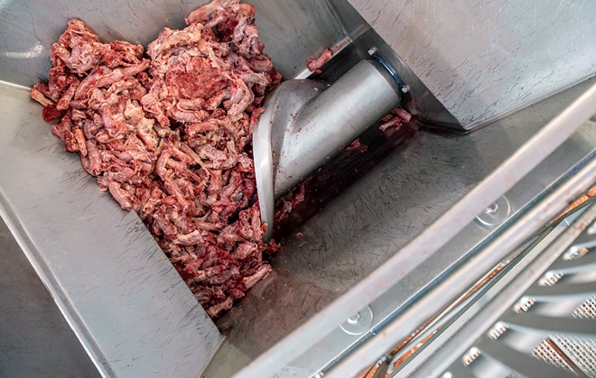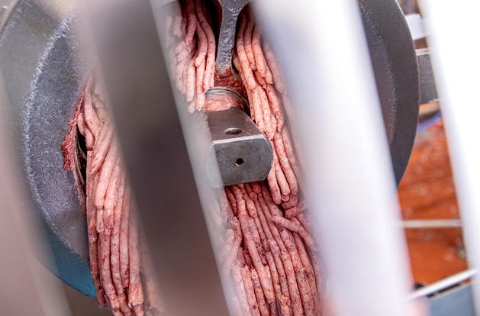
IMG_7843 and IMG_7860: The peeling edge of the feeder worm pre-cuts frozen and – as shown in this photo – ingredients containing bone, without squeezing them. At the same time, it gently conveys the material towards the meat worm by means of variably adjustable speeds. This results in a first-class cutting pattern.

