A small component with a huge effect
New Clear Cut cutting system from K+G Wetter offers decisive benefits for grinding
Significantly greater processing power, better cutting pattern, lower energy consumption: The new Clear Cut knife from K+G Wetter achieves significantly improved grinding results, the likes of which have never been achieved before. Lower energy consumption and wear also ensure cost savings when grinding.
The new knife was developed on the basis of the Clear Cut sorting knife, which has been exclusively fitted to the grinders and mixer grinders made since 2022 by the manufacturer of meat processing machines from the German State of Hesse. It has since met with an extremely positive response from customers. The Clear Cut grinder knife complements the cutting system and can be used individually or in conjunction with the sorting knife. The cutting pattern and cutting performance are outstanding in both applications.
By adding its Clear Cut sorting knife, K+G Wetter has once again significantly improved its sorting device, which is already accepted as highly efficient. The benefit this brings to meat processing is that undesired hard particles, such as pieces of tendon, cartilage or rind, are reliably discharged in large pieces, wasting virtually no meat. This prevents product loss and improves the quality of the finished product without incurring additional work and time.
The benefits of Clear Cut in a nutshell:
- Exceptionally easy handling – Clear Cut knives are used instead of conventional knives in a standard cutting set
- Significantly increased processing performance – saving both time and cost
- Even lower temperature increase – improving feedstock for further processes
- Better product flow – saving energy and, therefore, cost
- Less abrasion of the cutting set components – saving cost through longer resharpening cycles and service life
- Even clearer cutting pattern and red/white separation – delivering better end products
- In conjunction with Clear Cut sorting knives – outstanding, sharp sorting performance
The new Clear Cut knife can be combined with standard perforated disks and used for all applications aside from frozen meat.
“The newly developed Clear Cut family of knives delivers results with which we are more than delighted – indeed, they represent a whole new dimension when it comes to meat grinding. We can truly speak of a quantum leap in the development of cutting set components,” explains K+G Wetter’s Managing Director, Volker Lauber. “The benefits this delivers for our customers in terms of grinding efficiency and quality cannot be similarly achieved using conventional cutting set components.”
K+G Wetter will also be exhibiting its Clear Cut products at the SÜFFA 2023 trade fair in Stuttgart (21st – 23rd October, Hall 9, Stand A30).

Press photos: K+G Wetter

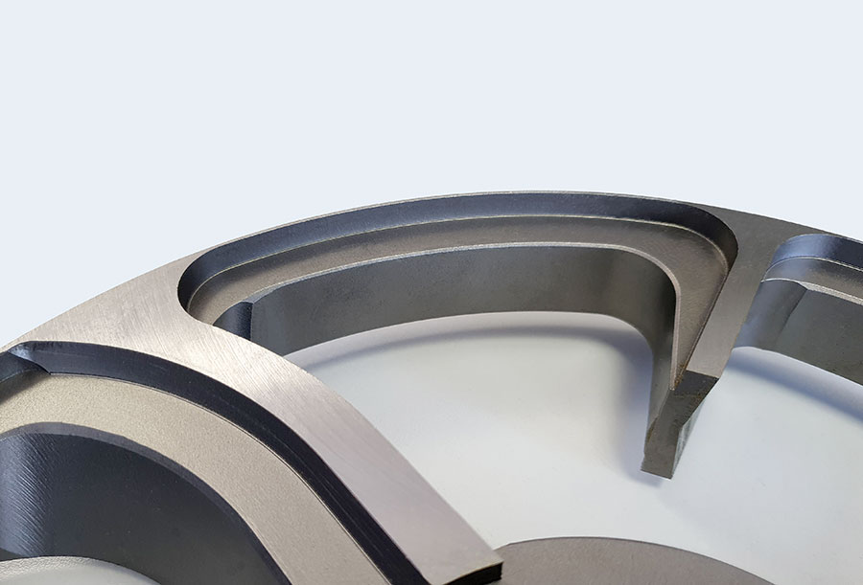
The knives of the Clear Cut System from K+G Wetter - here in the picture the sorting knife - ensure an unsurpassed sorting result and cutting pattern during mincing.

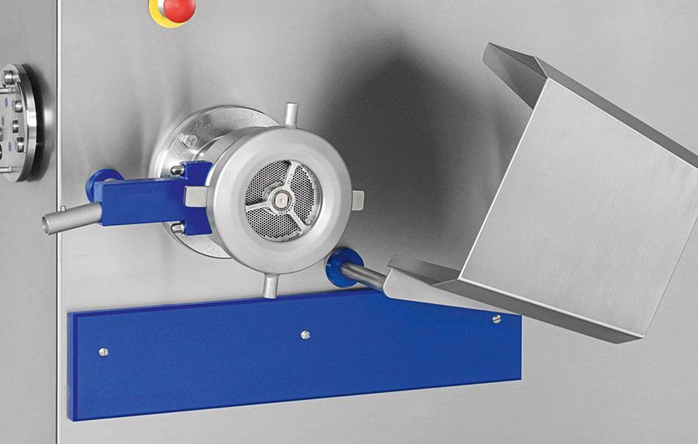
The new Clear Cut knife can be used with standard perforated discs and for all applications except frozen meat.

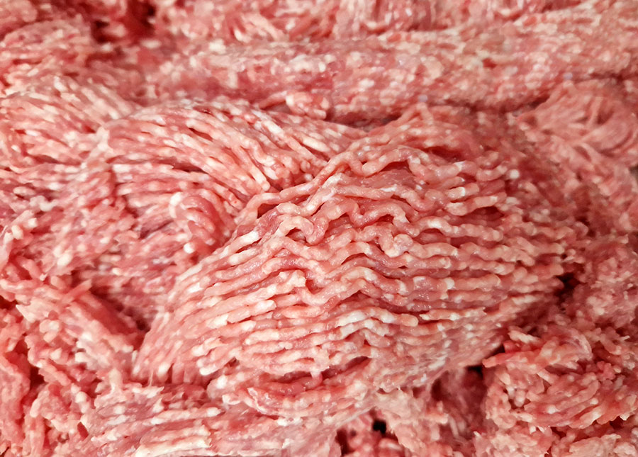
With the newly developed knives of the Clear Cut series, the grinders and mixer grinders from K+G Wetter achieve results that more than inspire and mean a new dimension in mincing: with an even clearer cutting pattern and red/white separation.

