CASE STUDY
K+G Wetter GmbH
February 2020
Werner Molitor Butchery, Kürten-Dürscheid

"We have found a partner on the same wavelength"

Best results guaranteed: The Molitor butchery depends upon cutters and grinders from K+G Wetter

With a small family-oriented team that includes spouse Rita, daughter Marion, son Matthias and son-in-law Stefan Schmidt, the Werner Molitor master butcher’s shop—now already in its second generation—continues to produce new sausage-based culinary creations in the tranquil Dürscheid area of Kürten (Rheinisch-Bergischer District). The range offered by the family-run company, which employs a staff of eighteen, encompasses over ninety different types of sausage. These are supplemented with seasonal specialities such as wild game sausages from the family's own hunts. "We take particular pleasure in surprising our customers' taste buds with ever-changing seasoning combinations or by creating original reinterpretations of proven classics such as our Mettwurst rings", comments Werner Molitor, head of the Bergisches Land Guild of Butchers and senior partner in the business, delightedly. "We only process meat of the very highest quality and purposefully avoid long transport distances. Aside from the basic materials—of course—a good sausage also needs careful processing that allows the meat’s natural characteristics to develop fully, in combination with the seasonings."

Completely customised for the workflow

Together with son Matthias and son-in-law Stefan, the senior partner in the business had therefore already been searching for an appropriate solution to complement the firm's own machine fleet for some time. "For us, investing in new machines is a question of safeguarding our livelihood", concludes Matthias Molitor. "In many areas our profession requires a great deal of physical strength, so the easiest possible handling and good ergonomic characteristics are among the decisive factors. The machine must adapt to the person – not the other way around." For producing in-house specialities it is intended to invest in a bowl cutter and an automatic grinder. In order to gain a good overview of potential production aids the Molitors first visited a wide range of trade fairs. "The machines are naturally thrust into the spotlight there and exhibited to best possible effect," grins Werner Molitor. "However, this still doesn't allow me to form an initial picture of their true characteristics in ongoing production." For this reason the family went a step further and visited several friendly businesses that were already operating machines from K+G Wetter. "Of course we exchange our experiences within the industry", explains son-in-law Stefan Schmidt, "the opinion of an expert colleague carries more weight for me than statements made by the seller." Following these visits it was clear that the machines would not only simplify the workflow, but also that they are designed with special attention placed on exceptional cleaning and hygienic properties.

Designed by experts for specialists

"In our daily workflow every detail aimed at achieving efficient and high-quality production is important to us. With the machines from K+G Wetter it became immediately clear that these had been developed by experts who understand the challenges facing us", postulated Werner Molitor. "Ninety different types of sausage also means the machines must undergo frequent cleaning runs between the individual batches. It is crucial that absolutely everything is just right in order to ensure we don't lose any production time, while still being able to manufacture the best-tasting sausages for our customers."

"The decision to install new machines brings with it particular consequences for a small family-run company like ours", explains Werner's wife Rita. "The investments must pay off and ultimately secure the future of our company."

Initial positive effects had already become apparent at the butcher's shop in Kürten shortly after procuring the machines. The bowl cutter, with a capacity of 70 litres, was not only more efficient in operation, but also impressed with some clever details. "During production we must, of course, constantly add ingredients. When the lid is opened the CM 70 automatically reduces the knife shaft RPM. It is also possible for the operator to very easily set the RPM himself. This significantly reduces noise exposure, thereby facilitating communication between the workers", reports Matthias Molitor.

Even during the first production runs with the automatic grinder it became clear that the decision to purchase the machines was the right one: "We are now able to add all of the materials for a batch at once and the feeder worm means that the need to fill the machine is completely eliminated", Marion Schmidt is pleased to report. "While the grinder is operating we are able to move around freely and can continue processing the ground meat without interruption."

Reliable partner on the same wavelength

The work of a master butcher is characterised by tradition, regional patriotism and knowing just how important the trade—and its future—is. Werner Molitor's team also expects these same high standards from its business partners. The service concept is a priority for the whole team: Being a reliable partner for customers is important to the Molitors.

Examples of this include the extensive party service and the "Hot counter": The range of products offers enjoyment to perfection. Whether rustic home cooking or gourmet buffets, the service is always tailored to individual requirements. "We are here for our customers and give our best to provide them with exactly what they want", explains master butcher Stefan Schmidt.

"We have rediscovered precisely this approach in all of our communications with K+G Wetter. We always had a direct and personal contact partner who professionally and quickly answered our questions. The experts at K+G Wetter were competent partners and were always available. And this level of service didn't end with the purchase of the machines. Our philosophy simply matches that of K+G Wetter. We have found a partner on the same wavelength", sums up Werner Molitor.

K+G Wetter GmbH
K+G Wetter is a sought-after global partner for manufacturing high-quality and reliable meat-processing machinery. K+G Wetter develops advanced cutters, grinders and mixers for butchers and skilled workers in the meat-processing trade and industry. The company's sophisticated technology and high-quality processing mean that machines from K+G Wetter contribute significantly to customers' business success. As a world-famous brand, the company from the Breidenstein district of Biedenkopf, in the German State of Hesse, supports its customers with personal and individual advice.
www.kgwetter.de

Press image 1:

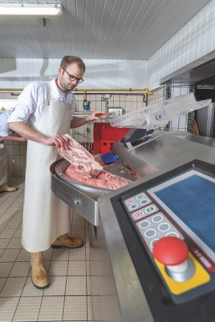
© K+G Wetter

Picture caption: Master butcher Matthias Molitor appreciates the fact that the cutter automatically reduces the RPM when he opens the lid to add seasonings to the sausage meat.
Press image 2:
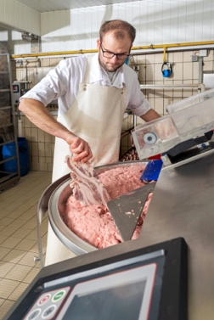
© K+G Wetter

Press image 3:
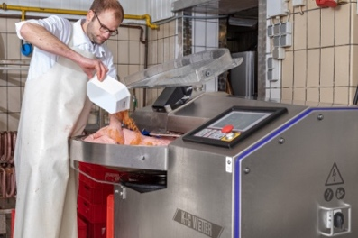
© K+G Wetter

Press image 4:
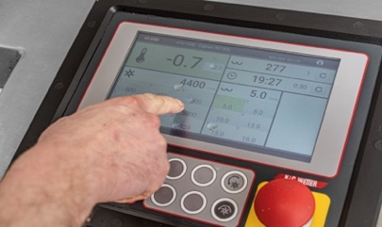
© K+G Wetter

Press image 5:
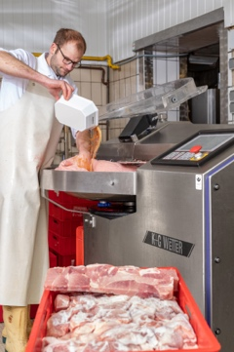
© K+G Wetter

Press image 6:
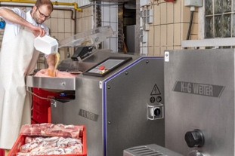
© K+G Wetter

Press image 7:
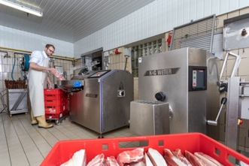
© K+G Wetter

Press image 8:
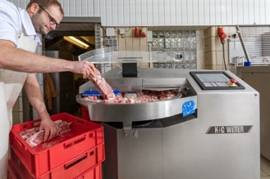
© K+G Wetter

Press image 9:
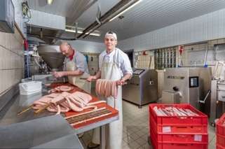
© K+G Wetter
Image caption: The five apprentices at the Molitor butcher's shop in the Dürscheid area of Kürten also benefit from the investments in modern machinery during their day-to-day work (pictured is Tom Grimberg, 1st apprenticeship year).
Press image 10:
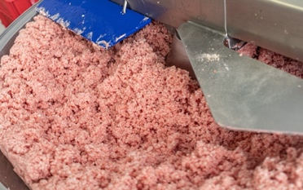
© K+G Wetter

Press image 11:
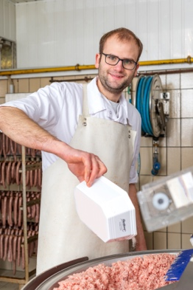
© K+G Wetter

Press image 12:
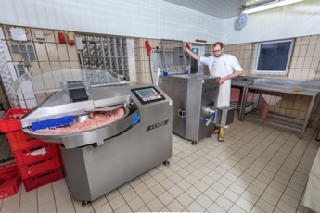
© K+G Wetter

Image caption: Thanks to the feeder worm, the need to fill the automatic grinder D 114 from K+G Wetter is completely eliminated.

Press image 13:
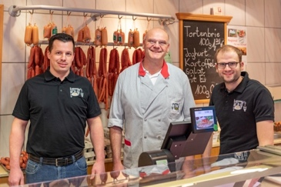
© K+G Wetter
Image caption: Equipped for the future: Master butchers Stefan Schmidt and Matthias Molitor together with head of the Bergisches Land Guild of Butchers, Werner Molitor (l to r).
Press image 14:
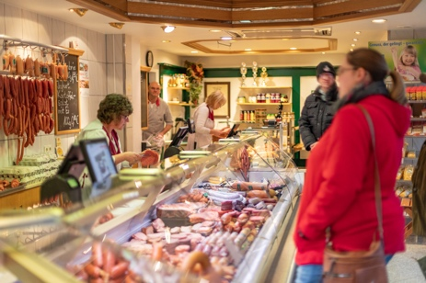
© K+G Wetter
Image caption: Over 90 types of sausage, supplemented with seasonal specialities such as wild game sausages from the family's own hunts, delight customers each day anew.

Press image 15:
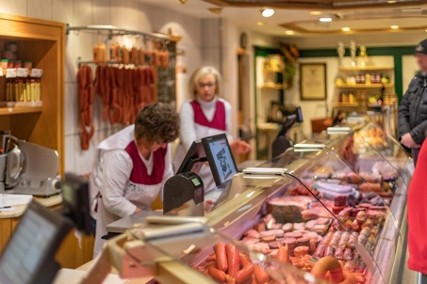
© K+G Wetter

Contact information:
K+G Wetter GmbH
Goldbergstrasse 21
35216 Biedenkopf-Breidenstein
www.kgwetter.de

Your contact partner:

Katharina Hennig
PR/Media
T. +49 (0) 2 71 . 77 00 16 - 160
F. +49 (0) 2 71 . 77 00 16 - 29
k.hennig@psv-neo.de

